Academic Year- 2016 - 17
Lead College Activity -2016
On behalf D. R. K College of Commerce Dept of Economics Lead College Activity conducted to enlighten the various stake holders about New Tax Regime i.e. GST (Goods & Services Tax). Students from various colleges & professors attended the programme. The chief Guest of the pragramme were Prin. Dr.V. A. Patil, Function was inaugurated in the hands of President Sou. Rajnitai Magdum, Secrete Adv. V. N. Patil, Prin. V.A.Patil ,C.A. Gangadhar Haldikar informed to the audience about New Tax Regime i.e. GST & its rate of taxes. He also informed to the audience as GST is one country one tax came into existence with mergin of various indirect taxes such as Sales Tax, Central sales Tax except custom duty. In brief speaker highlighted that this tax regime is nothing but One Country One Tax system which may stream line friendly tax regime in country.

Photo
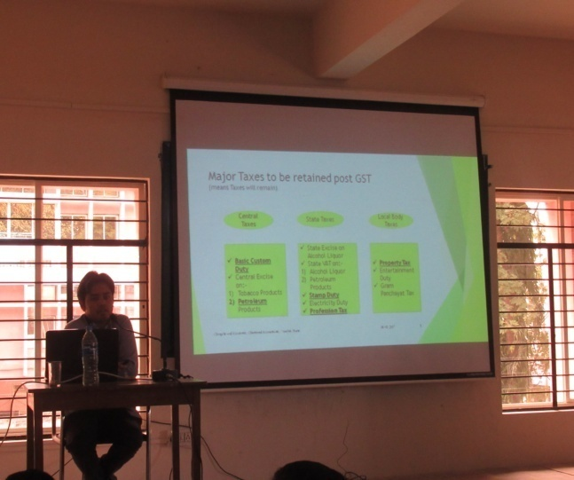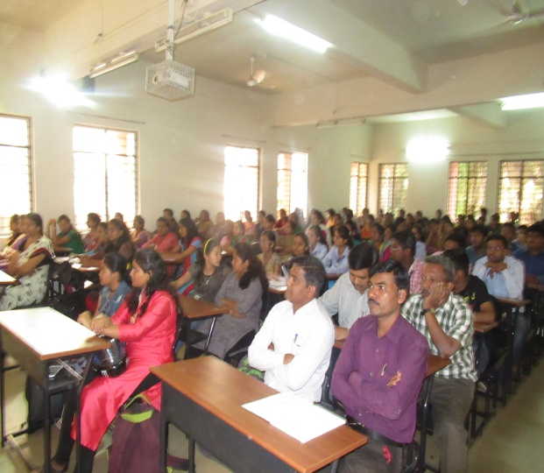
Outcome:
Faculty members, students from our college & outside colleges were benefitted. All of them were acknowledged with the new Tax regime which has been operationalised in India along with new tax rates & inclusion of various indirect tax rates .All the stake holders highly satisfied with the programme.
Workshop on “How to manage money & be a smart investor ------
Organized by NSE (National Stock Exchange) on 8th Sept 2016
About Workshop:
The workshop was organized in association with NSE to make the students aware about investment & career opportunities amongst students. This workshop was exclusively conducted only for the commerce stream students. Dr. Sitaram Dixit Chairman CGSI delivered the speech & informed to the students about various avenues & opportunities available in the stock exchange for career. Faculty members Dr. R. S. Naik, Dr. S. F. Bothikar, Miss. Samina Jamadar, Mr. P.M. Sorte & students were present.
Outcome of the Workshop :
The above programme largely benefited students who came to know various career opportunities in the financial sector. The students were enlightened that if they properly pursue the career in financial sector, more opportunities are there. In this regard various courses relating to stock markets are available, students were guided. At the end students were practically guided through the distribution of various pamphlets & booklets.

Population Day
On the eve of World Population Day on 11th July, a programme was organized in our college to celebrate the “Population Day”. The chief guest for this programme was Prin. Dr. S.B. Patil , Head, Dept of Economics. Introduction was done by Dr. R. S Naik. Other staff members Prof. B. T. Naik, Dr.S.F. Bothikar, Prof. Miss. Jamadar Samina & Prof. Mr. P. M. Sorte were present.
The chief Guests highlighted on responsible causes of growing population & its consequences. He reiterated that India is facing various economic problems such as poverty, unemployment & inequality. He also mentioned that our country is known as highly populated country in the world may likely to face food riots in future. At the end Chief guests made aware all the students about their responsibility in understanding the above issue & think over it .The above programme ended with vote of thanks.
Photo
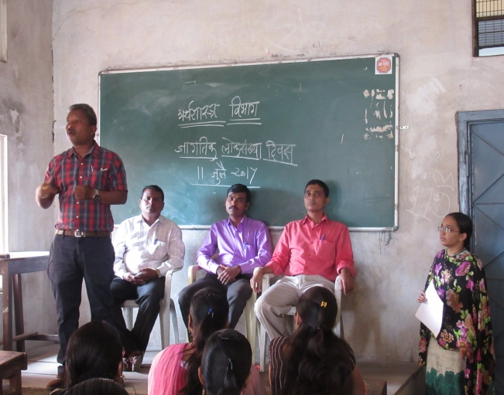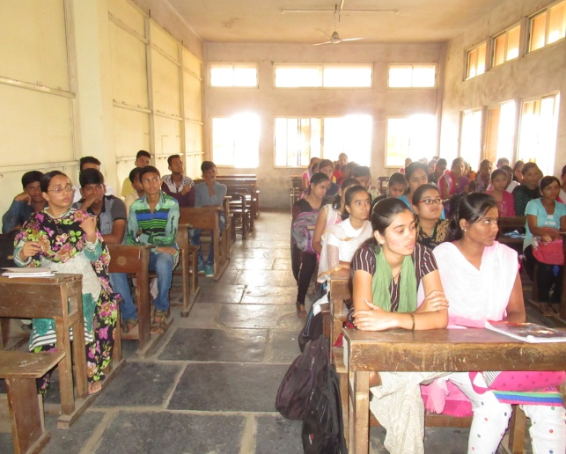
Outcome:
The above programme largely benefited students by making aware them about current issues. The students were seriously provoked to think over population issue. This programme was celebrated with the establishment of Planning Forum. Students were provided platform to express their views pertaining to economic issues. The intention of the programme fulfilled with larger response from the students.
Academic Year ( 2017-18)
Population Day 11th July 2017
On the occasion of World Population Day An Essay Competition was organized. The main topics were
1) Challenges of Population Explosion
2) Population Boon or Bane
3) Population Policy: Success & Failure
Near about 47 students were participated
Result
English Medium:
1) Miss. Myuri Mahagaonkar (B.B.A II)
2) Nadini Majethia (B.Com I)
3) Youraj Desai (B.B.A.I)
Marathi Medium:
1) Dattray Chougule (B. Com I )
2) Shewata Salokhe ( B.Com I)
3) Arshiya Makandar ( B.Com I)
All the winners were felicitated in the hands of principal
Outcome:
The above event provoked the students to think over the Population problems being faced not only by our nation but also entire world .Such ever really promoted the students to think & write analytically. It also helped the students to improve drafting & thinking level which are highly necessary in the present competitative field.

Message Contest
Message contest celebrated on 30th Dec. 2017. All the students were participated & they were given the situation on which economic terminologies were allowed to use. The above event organized to test the knowledge about the subject.

Photo
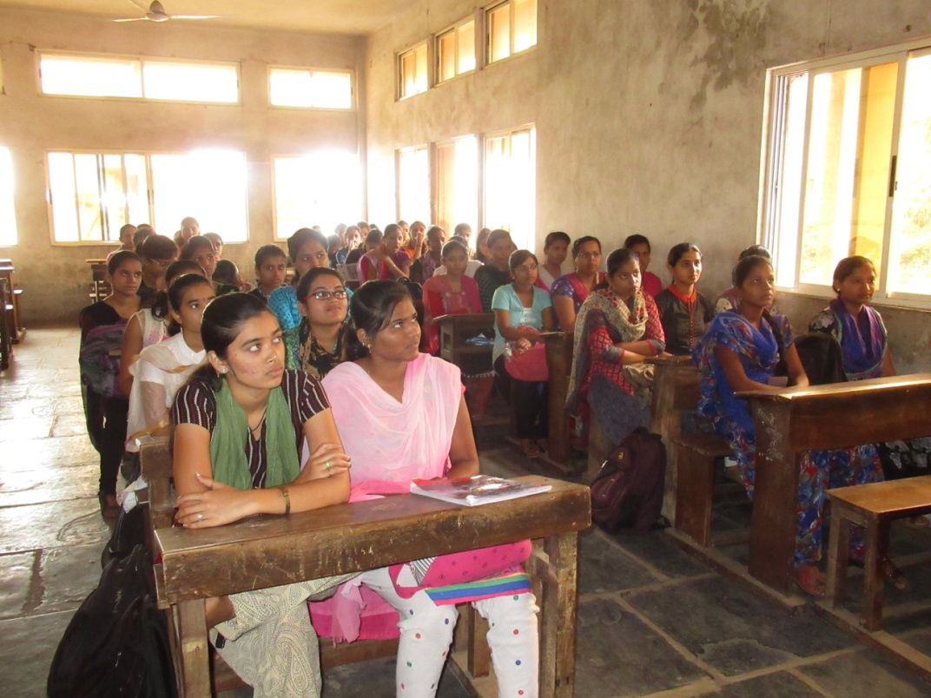

Outcome:
The above event helped the student to develop memory retention capacity. It also helps in nurturing the talent for appearing to the competitative examination. The above event was appreciated by all the students.

Academic Year - (2018 – 2019)
“ Economics of Shravan Month”
On behalf of Department of Economics Open Forum activity on the subject “ Economics of Shravan Month” organised on 31st Aug. 2018. The students from all classes were allowed to participate .As this was a Open Forum activity, the students were made aware to share the economic with festive incidents how they are commercialized. Eighty Five students were participated.
Photo

Output :
The above event helped the students to develop courage about sharing of knowledge with other students on the plat form. It also made the students to think about how festivals are being commercialized. The students also shared the live examples of advertisement of Suzuki Motors India Limited, Samsung, Sony LG & other cosmetic manufacturers such as HUL, Colgate Dabur etc. The above event truly became helpful to the students to remain abreast of present economic situation.

Group Discussion (Union Budget -2019)
Group discussion event on the Topic Union Budget - 2019 organised . Students were given pre intimation about to study the budget. The were appealed to express the opinion & contribute to the subject. The above event started with introductory Speech by Prof. Ashok Pawar who enlightened the students about basics of Budget. Later students were permitted to speak .All of them contributed to different issues independently. Later Prof. B.T.Naik, Prof. Mrs. Thipkurle madam contributed by expressing their opinion. The function was concluded with vote of thanks by Prof. Pooja Nikam Madam .
Photo :
Outcome:
The above programme largely benefitted to the students by way of upgrading their knowledge. Students became conscious about budget procedure as entire event was relevant to curriculum .The students were also enlightened about the basics of budget & resource allocation. There was satisfactory response from the students.

D.R.K. College of Commerce, Kolhapur.
Department of Economics
UNION BUDGET SPEECH 2020.
Union Budget Speech Programme was organized on 5th Feb 2020 at 10 .00 AM
Resource Person :
Prof. Prakash Kamble Head, Department of Economics, Shivaji University, Kolhapur.
Report of the Programme :
Prof. Prakash Kamble spoke about the Union Budget 2020 and informed to the students about concept, purpose of the Budget & its way of working.In his speech he given detail insight about how revenue & expenditure are collected and disbursed. He also shed light on various aspects such as Direct & Indirect Tax rates, provision for allocation of funds for priority sector such as agriculture and infrastructure .In the interaction programme students were actively participated & raised queries. Entire programme largely benefitted B.com II students as the overall discussion was interconnected with the Topic: Public Finance from their Curriculum. Gymkhana Chairman Prof. Dr. Bansode Sharad, HOD: B.T.Naik, Dr.R.S.Naik, Prof. Miss. Jamadar Sabina, Dr. Bothikar S.F., Prof. P.M.Sorte and students were present.
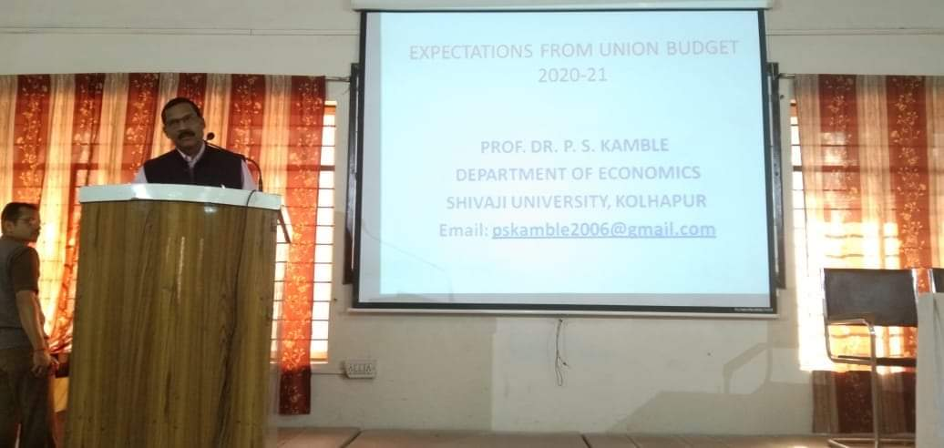
Outcome:
The above programme created interest amongst the students. As the entire speech was related Union Budget 2020.The students also asked the various queries about provision of budget, allocation & revenue & expenditure of the govt. This programme helped to enlighten the students about various issues relating to budget.
DEPARTMENT OF ECONOMICS
Debate Programme On Bank Merger: Organized on 14th Sept 2019
Participants: Students from B.Com II & B.Com III and staff members participated
Report of the Programme:
On the eve of merger of nationalized banks declared by the Finance Minister Nirmala Sitharaman, a debate programme was organized.Initially students were well acquainted with the merger of banks and its purpose such as Vijaya bank merged with Bank of Baroda, Punjab national bank with Orient Bank of Commerce. The students also informed about the purpose of the merger & well acquainted with the above subject.
The debate programme exclusively instigated the students to express their opinion about Merger. Raksha Kamat, Apoorva & other students expressed their views in favor of and against the merger.The entire programme succeeded with by realizing the students to remain abreast of the recent developments pertaining to the subject.At the end senior faculty members Prof. B.T.Naik,Dr. R.S.Naik & Dr. S.F.Bothikar, Dr.Samina Jamadar & Prof. P.M. Sorte contributed their views in this programme. Gymkhana Chairman Prof Mrs. Bhakti Nerlekar appreciated the students about their knowledge and motivated them.
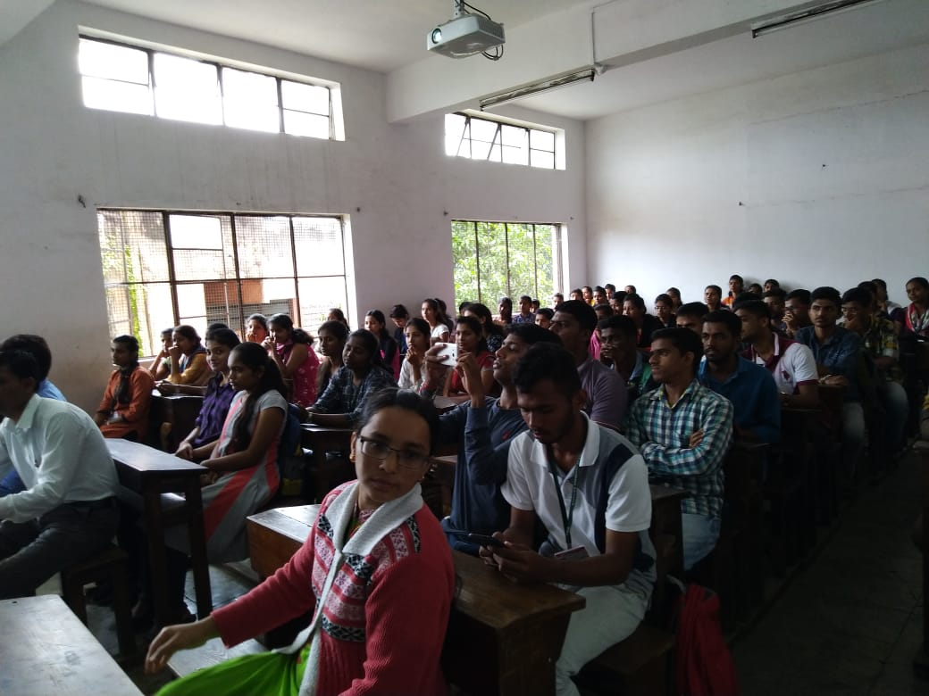
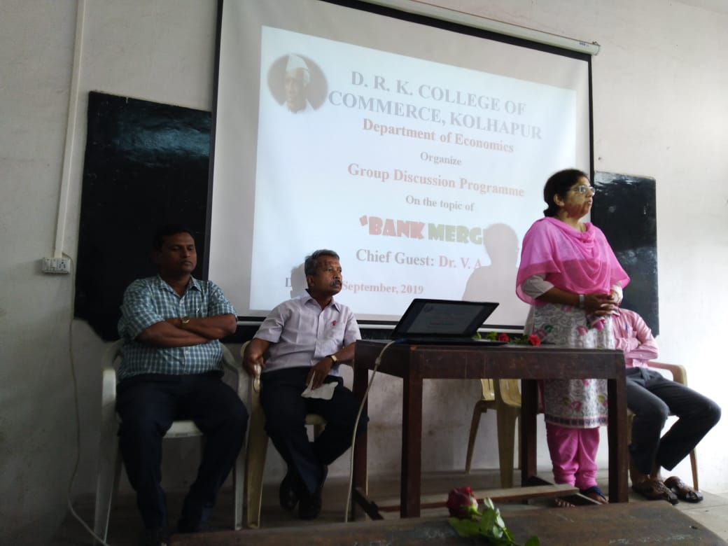

Outcome of the Programme:
The debate programme became grand successful with more students actively participated and contributed significantly towards new issue i.e. bank merger. Raksha Kamant, Apporva & other students expressed their opinion in favors & against the merger. The students stated that the merger will axe the employment opportunities whereas someone said it will improve the efficiency. By the way this event developed the courage & awareness amongst the students.

